# Q1.

Code:

HTML:

<!DOCTYPE html>

<head>

    <title>Color Change</title>

    <script>

    let i = 1;

    const color = ["red", "blue", "green", "yellow", "purple", "orange"];

    function colorChange()  {

        document.body.style.backgroundColor = color[i];

        i++;

        if (i == 6) { i = 1 }

    }

    </script>

</head>

<body>

    <button type="button" onclick="colorChange()">Change!</button>

</body>

</html>

Screenshots:

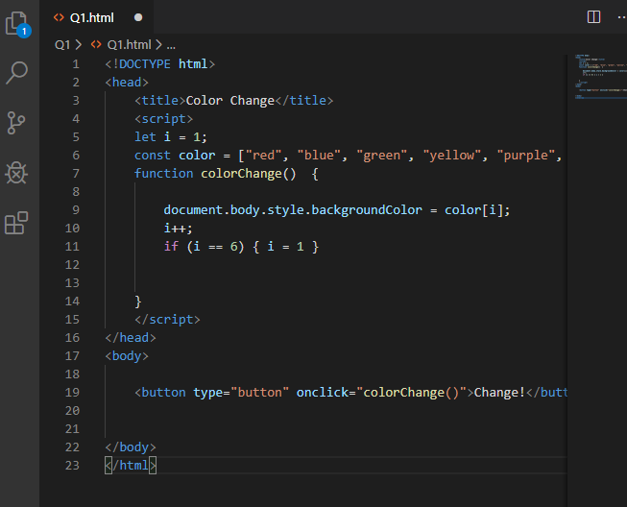

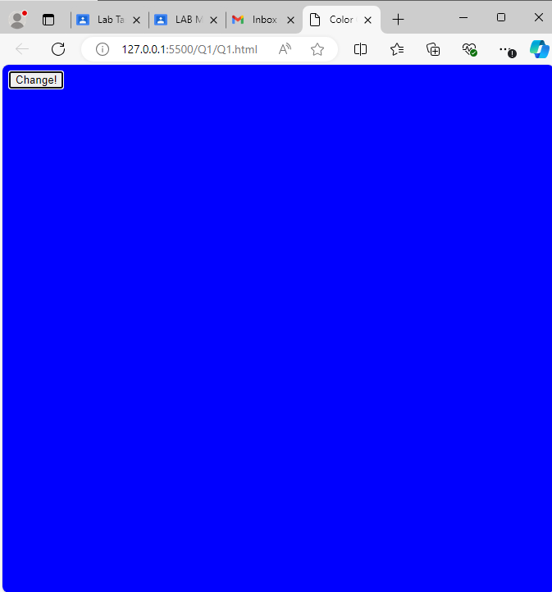

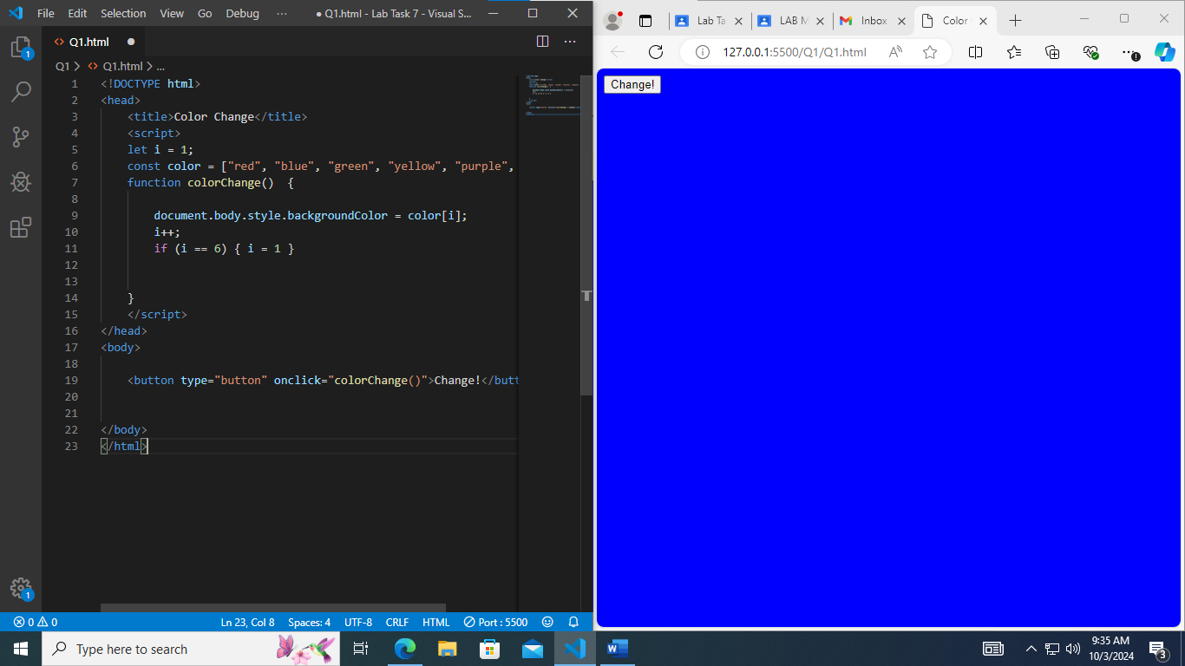

# Q2.

Code:

HTML:

<!DOCTYPE html>

<head>

    <title>ALERT</title>

    <style>

    body    {

        background-color: aliceblue;

    }

    .checkbutton {

        padding: 200px;

        align-items: center;

        box-shadow: 0px 2px 10px rgba(0,0,0,0.1);

    }

    </style>

</head>

<body>

    <script>

    function alertMessage()    {

        alert("YOUR COMPUTER HAS A VIRUS")

    }

    </script>

    <button onclick="alertMessage()" class="checkbutton">Check Ma PC</button>

</body>

</html>

Screenshots:

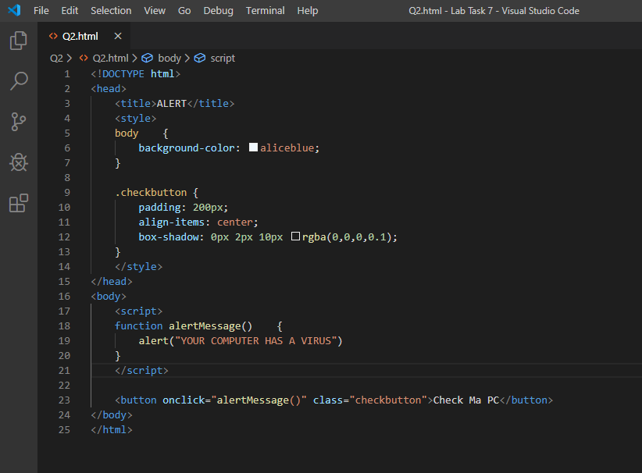

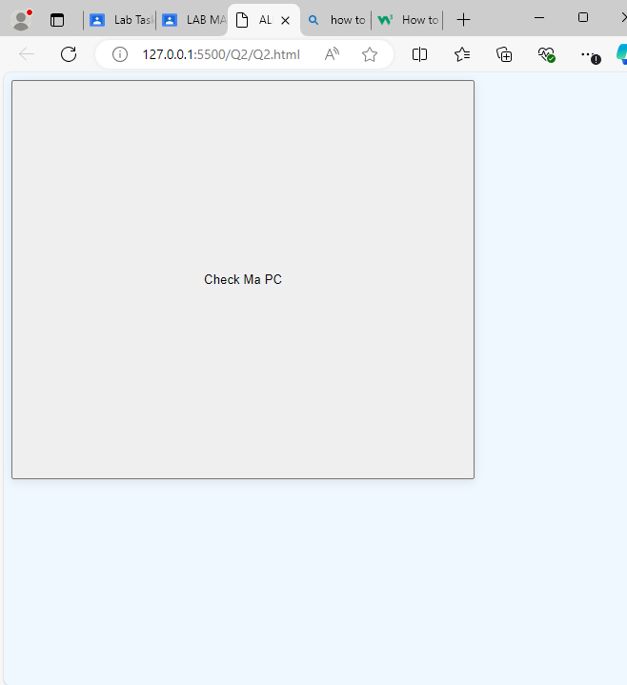

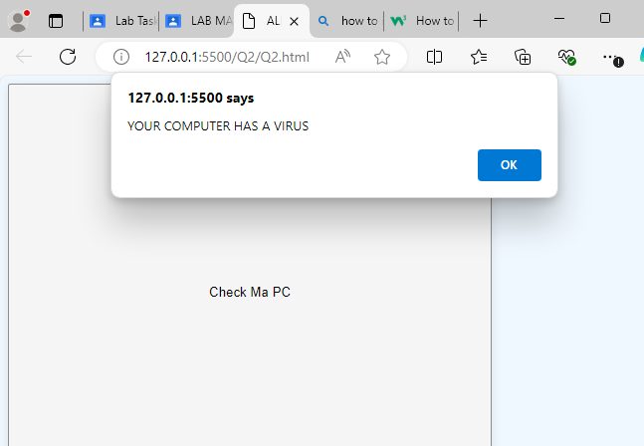

# Q3.

Code:

<!DOCTYPE html>

<head>

    <title>Calculator</title>

</head>

<body>

    <input id="numA">

    <input id="numB">

    <script>

    function addNums()  {

        document.getElementById("answer").innerHTML = parseFloat(document.getElementById("numA").value) + parseFloat(document.getElementById("numB").value)

    }

    </script>

    <button type="button" onclick="addNums()">ADD!</button>

    <p>The answer is: </p>

    <p id="answer">0</p>

</body>

</html>

Screenshots:

